ASR

Description: add SKU FTA requirement remark in Validate Shipment Report.

**From:** Zhi Ai, Huang   
**Sent:** Thursday, 06 August, 2015 11:04 AM  
**To:** Chan, Pei-Fong  
**Cc:** Jack, Fong  
**Subject:** Additional information show on validation list

Hi PeiFong,

Current BD has required to get CoO information before shipment PGI and get alert to all CS to apply CoO before invoice generation.

So we would like to seek your advice whether any possibility to set the affected materials in WMS master list and to reflect “FTA” on validation list when shipment validation.

The concept similar like labeling project which test in last time.

Enclosed sample of validation list and FTA materials summary for your reference,

Kindly give your comments if any to move on.

System changes:

1. SKU Mapping:

SKU.susr4 = “FTA”

1. Applicable for Ship-to Countries:

Currently is for China, Korea, India, Philippines, Thailand, Indonesia.

Codelkup.ListName = ‘CTRYFTA’

CN China

ID Indonesia

IN India

KR Korea

PH Philippines

TH Thailand

WMS Update:

1. System Code

ListName = ‘**CTRYFTA’**

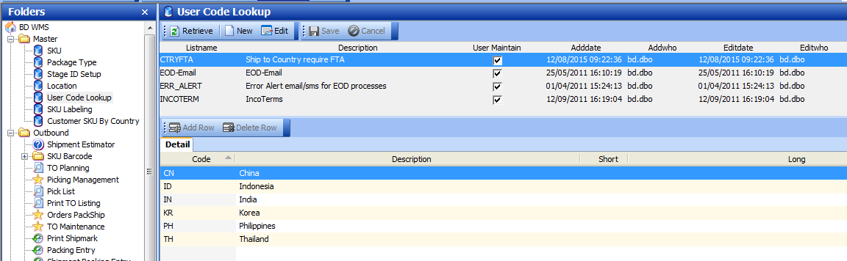

1. Master - SKU

Added new field in SKU for FTA indication.

To Update “**FTA**” for require SKU .

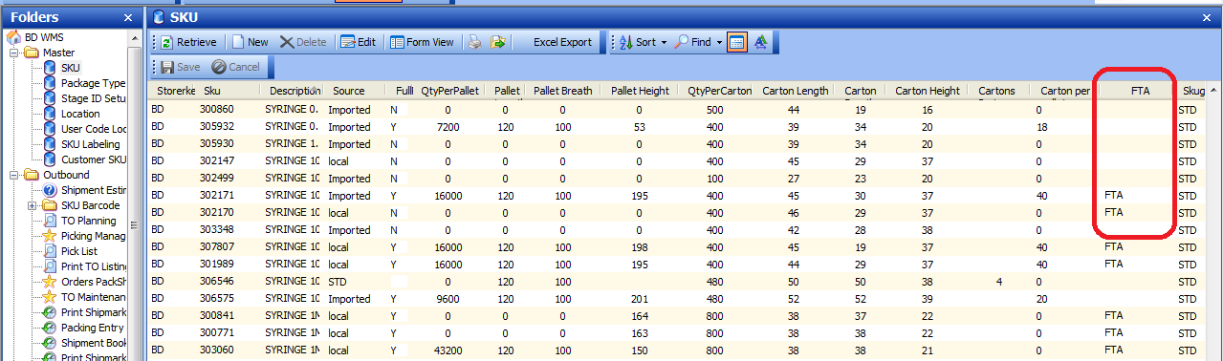

1. Report – Shipment Validation report

